**Combinatorial Game Theory**

中文：

可作为大纲：

<https://www.cnblogs.com/candy99/p/6548836.html>

超详细版：

<https://blog.csdn.net/tongyongzh/article/details/6175034>

<http://www.cnblogs.com/tanky_woo/archive/2010/08/20/1804464.html>

<http://acm.hdu.edu.cn/forum/read.php?tid=11339&fpage=0&toread=&page=1>

英语版：

超详细的textbook

<http://ishare.iask.sina.com.cn/f/17425887.html>

http://acm.hdu.edu.cn/showproblem.php?pid=3032

# Outline:

## First lesson—Go play some games

**Objectives:**

1. Learn about basic concepts;
2. Learn the presentation and notation used in game theory;
3. Identify different combinatorial games in daily life.

**Content (30min):**

1.1 a simple take-away game as introduction.

1.2 What is a combinatorial game?

Definition of combinatorial games;

Difference between impartial and partizan games;

Difference between normal and misere play rule.

1.3 The game graph

Figure of a game graph;

Definition of terminal position and height.

1.4 N-position and P-position

Definition of N, P-positions;

Theorem: every position in impartial combinatorial game is either P or N;

Exercise: identifying N,P positions in simple take-away games.

1.5 Application—solving the game

Provide an exact example of how to use what we learn in this lesson to solve a take-away game.

**Homework (10min):**

Identifying combinational games.

Solve a take-away game, and an Empty-and-Divide game.

## Second lesson—Nim!

**Objectives:**

1. Learning the additions of games;
2. Applying the addition of games in Nim games;
3. Proving several theorems and construct an incomplete Nim table;
4. Learn MEX rule to construct the whole Nim table;
5. Using the Nim table to solve games.

**Content (35min):**

2.1 What is the rule of a Nim game?

Explain the rule;

Play one round together.

Exercise: prove that a Nim game is an impartial combinatorial game

2.2 Nim-Sum

Definition

Theorem: A position, (x1, x2, x3), in Nim is a P-position if and only if the nim-sum of

its components is zero, x1 ⊕ x2 ⊕ x3 = 0

2.3 Nim table

Theorem: For any two numbers X and Y, there exists at most one number Z such that X∗+Y ∗+Z∗

is a P-position;

Working out part of the Nim table;

2.4 MEX rule

Definition

Application of MEX rule to compute the whole Nim table.

2.5 Using the Nim table.

Work out an exercise together hat uses Nim table to solve.

**Homework (10min):**

Focus on the practice of calculating different Nim-sums and applying MEX rules.

## Third lesson—Sprague-Grundy Theorem—playing games all at once!

**Objectives:**

1. Learn the equivalence of games;
2. Learn to play Nim with any number of piles;
3. Learn how to play all impartial combinatorial games using numvalue;
4. Summary on what we learned;
5. Provide the ultimate question.

**Content (40min):**

3.1 Equivalence of games

Definition

Theorem: g1≃g2 if and only if g1+g2 is a P-position.

3.2 Playing any piles of Nim game

Example of a 5 pile Nim game

3.3 Sprague-Grundy theorem

Definition of nimvalue;

Theorem (Sprague-Grundy): Any position g in a impartial combinatorial game is equivalent to a nimheap. In other words, there is some nonnegative integer X such that g ≃ X∗.

Example of using SG theorem on a take-away game.

3.4 what we have learned

3.5 what else we can explore

3.6 try the ultimate problem using what you have learned:

Remember the Empty-and-Divide game we did at the first lesson?

What will happen if there are three Empty-and-Divide game playing together?

i.e. there will be three heaps, each divided into two piles, and Player A and B can choose any of the heaps, take one of the two piles, and split the other pile into two piles. Whoever cannot move, i.e. left with three piles of (1,1), loses.

Can you work out the Nim table for this game? Can you work out the formula/algorithm behind?

**Homework (/):**

Question of 3.6 asked in class.

1. Give examples of some combinatorial games

* Hackenbush
* Push, shove, runover

1. The definition of combinatorial games

* No dice & No cards
* 2 players, soli…is not
* No random moves
* No ties, e.g. chess is not a combinatorial game
* Finite, doesn’t go on forever.

e.g dots and boxes

Rock-Paper-Scissors is not a combinatorial game, since the two players move simultaneously.

Most card games are also not combinatorial, since usually a player does not know what cards her opponent has or what cards she herself will draw on the next turn.

1. Problems to think about

Take-aways games

The game of Nim

**Introduction to a new game: cut cake**

What does it mean to play games together?

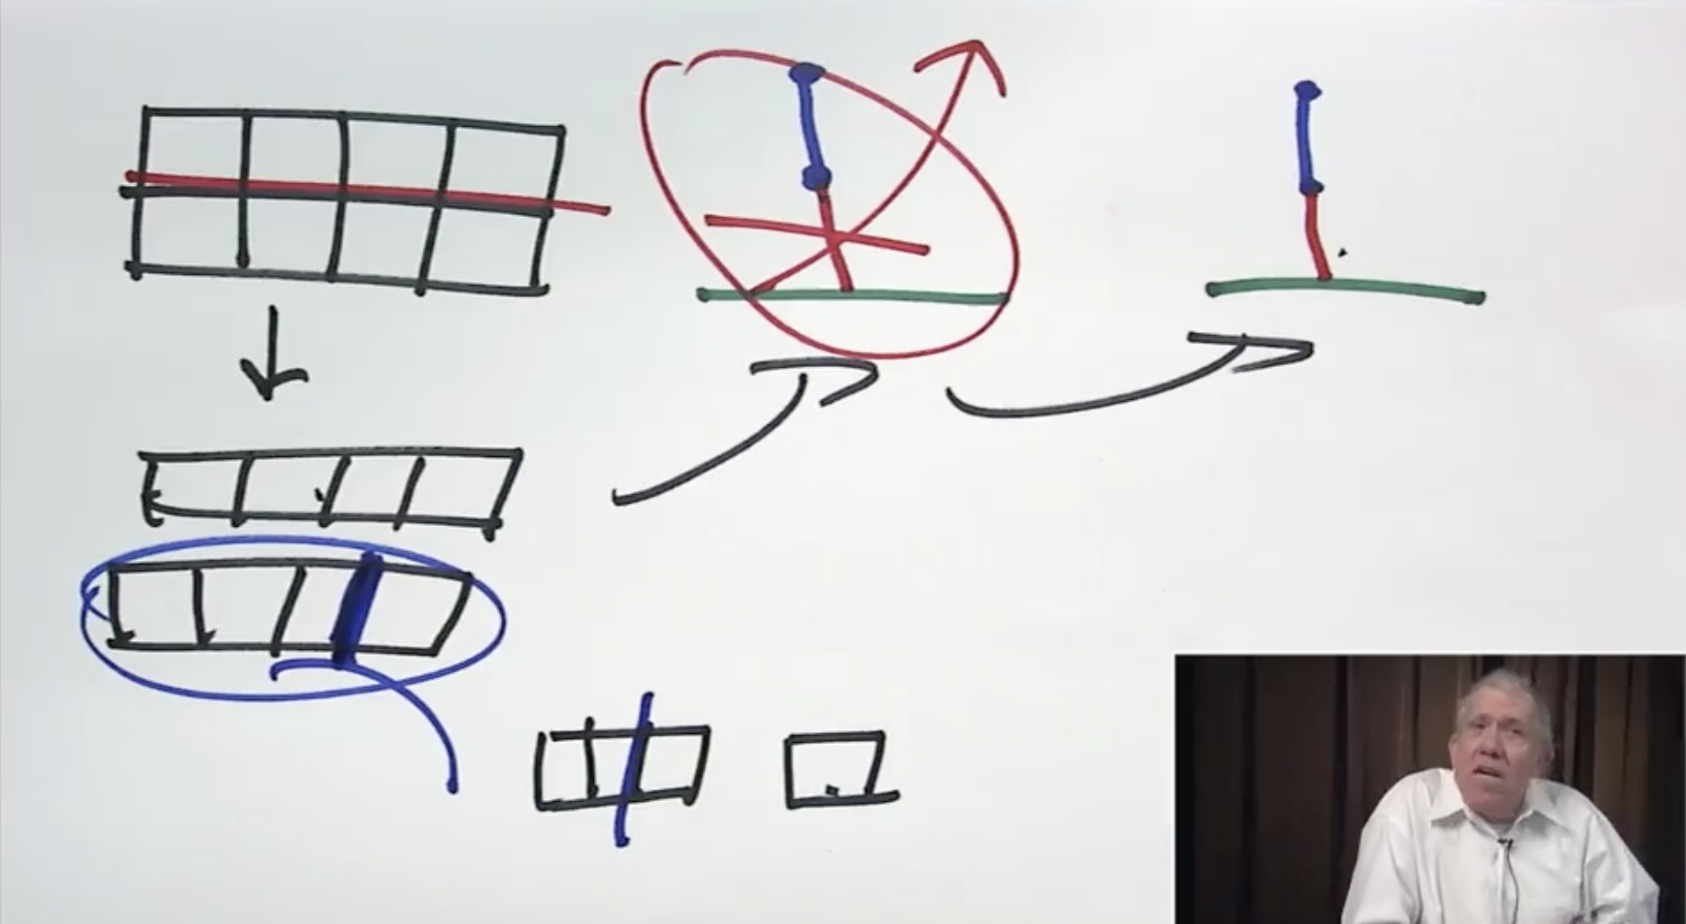

What does it mean that two games are equal?

What does it mean that a game is 0?

* Best play 1st play move loses

Nim game example

What is a negative game?

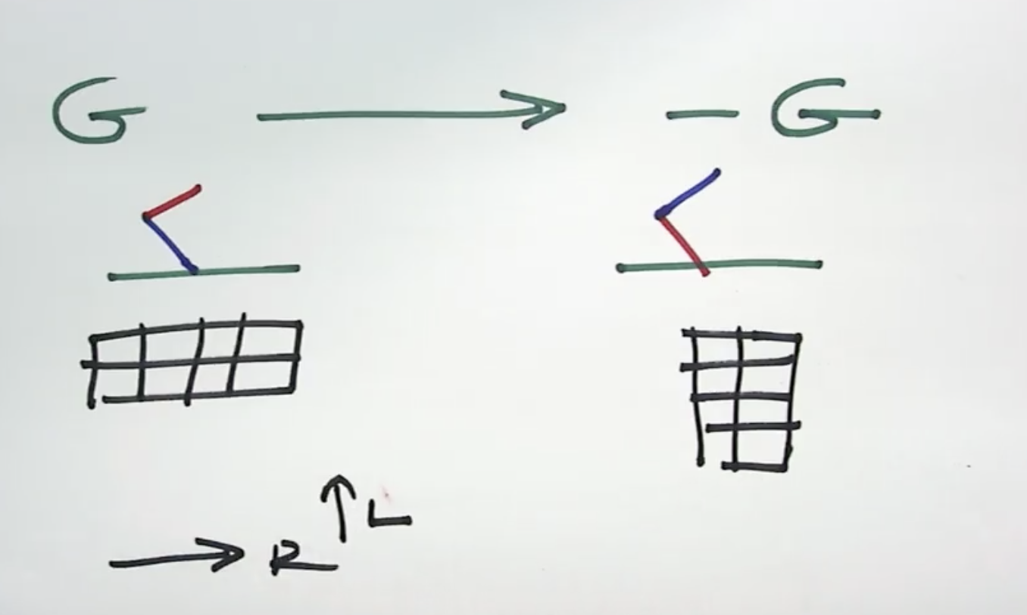

Formal definition

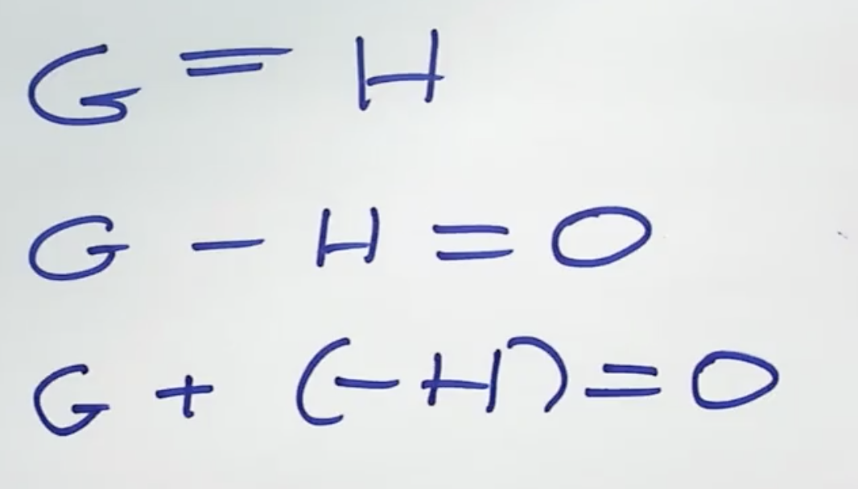

* Definition of the 0 game, the negative of a game.

* Examples from Hakenbush

* Problem and solution

* The Tweedledee- Tweedledum principle.

* Proof that G – G =0. Problem and solution.

* Homework/Quiz

Second lesson:

Graph games

Sums of combinatorial games

Third lesson:

Coin turning games

Green Hackenbush

<https://www.coursera.org/learn/combinatorial-game-theory/lecture/dCh8U/introduction-to-two-players-left-and-right>

### **Week 1**

* Let's play a game: Students will learn what a combinatorial game is, and play simple games

* Introduction to the two players: Left and Right. Ending rules.

# Some new games: Hakenbush, push, shove, run over.

* What is NOT a combinatorial game: dice, cards, etc.

* Formal definition of games in terms of left and right options.

* Problems and Solutions

### **Week 2**

* Playing several games at once, adding games, the negative of a game. Student will be able to add simple games and analyze them.
* Definition of the 0 game, the negative of a game.

* Examples from Hakenbush

* Problem and solution

* The Tweedledee- Tweedledum principle.

* Proof that G – G =0. Problem and solution.

* Homework/Quiz

### **Week 3**

* Comparing games. Students will determine the outcome of simple sums of games using inequalities.

* Definition of game inequalities in terms of who does better. Problem and solution.

* Using best play to decide Inequalities. Problem and solution.

* The games 1,2,3,….,-1,-2,…, Examples from Ski jumps

# Problem and solution.

* The game ½ = {0|1} .Proof that ½ + ½ = 1

* Other dyadic rational number games..

* Games that are not numbers: ⋆,↑, others. Problem and solution

* HW/quiz

### **Week 4**

* Simplicity and numbers. How to play win numbers. Students will be able to determine which games are numbers and if so what numbers they are.

* When is a game a number?

* If a game is a number, then which number? How to play numbers

# Examples. Problem and solution

* Examples from the games Cut Cake and Maundy Cake.

# Problem and solution

* HW/quiz

### **Week 5**

* Simplifying games: Dominating moves, reversible moves.
* Students will be able to simplify simple games.

* New ways of simplifying games. Dominated moves, reversible moves.

# Problem and solution

* Examples of reversible moves from Nim.

# Problem and solution

* More simple games: Up, Star, Down. Adding these.

# Problem and solution

* Examples from toads and frogs

# Problem and solution

* HW/quiz

### **Week 6**

* Nim: Students will be able to play and analyze impartial games.

* What is nim and how to play it. Nim sums.

# Problem and solution

* Definition of Impartial games Reversible moves in impartial games

# Problem and solution

* Examples of reversible moves in impartial games. The minimum excluded positive integer function.

# Problem and solution

* All impartial games are equivalent to Nim

* HW/quiz

### **Week 7**

* Where to go from here:

* The small small small world: games that are infinitesimal

* The Big Big Big world- Games that are infinite

* Some open problems in combinatorial games.